NAME: EXAM 2, Part 2 EN 585.405 - Physiology for Applied Biomedical Engineering Material Covered: Weeks 6 – 10 Administered During: Week 11 Questions 22 – 25 are worth 4 points each – answer all of them

22. Which change in a parameter (A or B, below) would cause a greater increase in resistance to blood flow through a blood vessel? Chose the correct response and explain briefly (equations are nice; define your parameters [e.g., R = resistance]).

A. An increase in blood viscosity by a factor of 2.

B. A reduction in vessel radius by a factor of 2.

If we consider the blood vessel a s a pipe, we can look at Poiseuille’s equation: Q = (𝜋 • ΔP•r4)/(8•𝜂 • l) which from R = ΔP / Q gives us that the resistance to blood flow is:

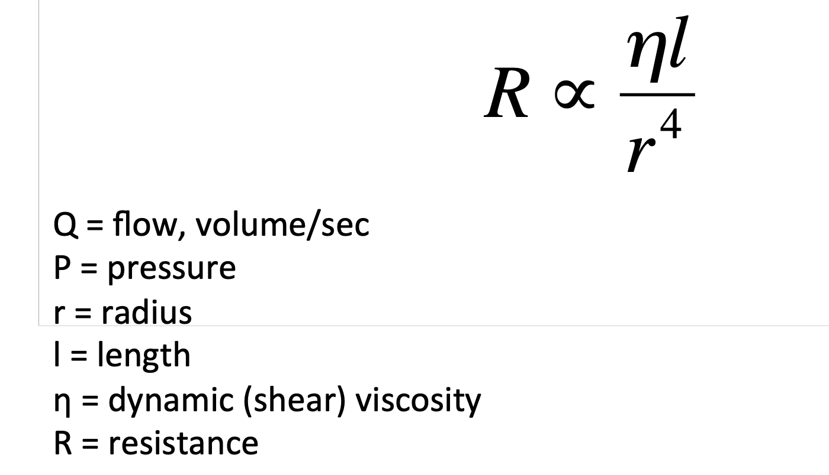

Since R the resistance, a reduction in vessel radius by half multiply the resistance by 2^4=16 which is larger that an increase in blood viscosity by a factor of 2 which will double the resistance so the answer is B.

23. An individual has a systolic blood pressure of 120 mmHg, a diastolic blood pressure of 81 mmHg and a cardiac output of 6 liters/minute. What is this individual’s total peripheral resistance? (Show your work).

The total peripheral resistance, TPR is given by:

TPR = (MAP – CVP) / CO

CO: cardiac output

MAP: mean arterial pressure

CVP: central venous pressure

At first order estimate, CVP is small compared to MAP which leads to:

TPR ≈ MAP / CO

And MAP ≈ Pdiag + 1/3 (Psys – Pdiag) = 81 + 1/3 * (120 – 81) = 81 + 13 = 94 mmHg

So TPR = 94/6 = 15.66 mmHg . mn/l

24. A patient is referred for a cardiac catheterization. The results of the catheterization show that, at mid-diastole, the patient has a left atrial pressure of 23 mmHg; at the same time the patient’s left ventricular pressure is 5 mmHg. Please briefly explain/discuss a possible cause for these observed results.

A possible cause could be a mitral valve stenosis**. Mitral valve stenosis** results from a narrowing of the opened mitral valve orifice so that it is more difficult for blood to flow from the left atrium (LA) into the left ventricle (LV) during ventricular diastole. The elevated resistance across the stenosis mitral valve causes blood to back up into the left atrial atrium, increasing left atrial pressure. This results in the LA pressure being much greater than the LV pressure during diastolic filling.

In a normal heart the pressure gradient across the valve is very small (see figure module 7, video 2, slide 2), the pressure gradient can become quite elevated in the case of severe stenosis.

See second figure, the shaded area separating the LAP from the LVP during diastole represents the elevated pressure gradient that is characteristic of mitral stenosis.

Mitral valve stenosis is associated with diastolic murmur because of turbulence that occurs as blood flows across the stenotic valve.

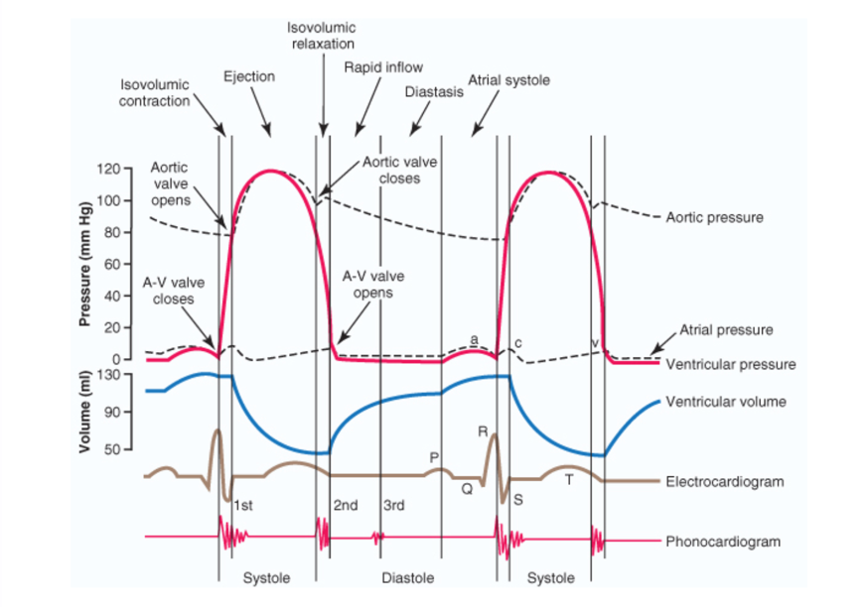

Module 7, Video 2, Slide 2

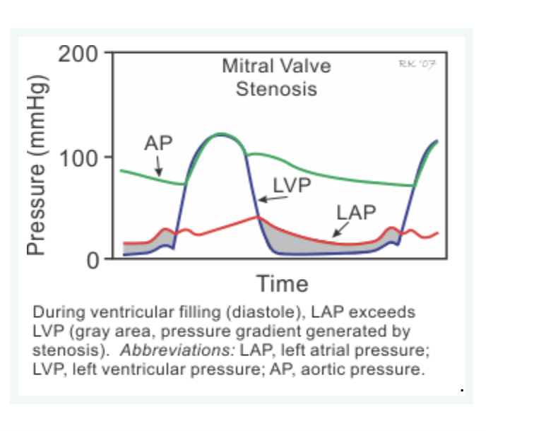

Source for Figure: https://www.cvphysiology.com/Heart%20Disease/HD004

25. In an experiment in which fast action potentials were measured in single isolated cardiac myocytes it was observed that administration of a particular drug resulted in a decrease in the duration of phase 2, along with more of a “droop” (negative slope) in phase 2. We know that the drug administered was not a calcium channel blocker. Provide a possible explanation for the observed results.

The duration and “droop” of phase 2 of the cardiac fast action potential are determined by inward Ca2+ current (for the most part, L- type Ca2+ channels) and outward K+ currents (IK1, IKr and IKs), see below. If the drug was not a calcium channel blocker, the potentiation of outward potassium current IK1, IKr and IKs will contribute to the same effects, so we can assume that the drug is enabling more of these currents (opening more voltage-gated potassium channels IK1, IKr and IKs).

